Pilates Ring, 38 CM, Magic Cercle, Exercise Ring, Double HandleHigh quality strips, moderate elasticity, no deformation under high pressure.
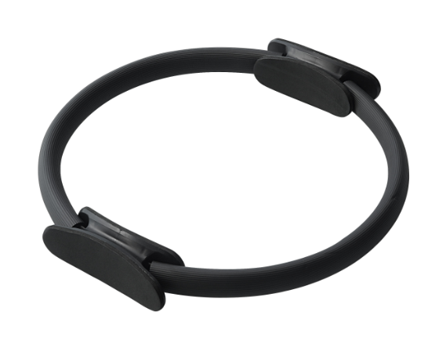

About this item
- SHAPE & BUILD & TONE | Great for those looking to develop muscle strength, increase body awareness, improve endurance, balance, and correct posture.
- PREMIUM QUALITY & STURY | Made from high quality PP and EVA material, the pilates circle is non-toxic, high density and durable, it won't crack easily even after strenuous exercise.
- ERGONOMIC DESIGN | The pilates ring set is small, light, and effective. It is easy to carry and store, excellent for taking to the workouts at home gym or when traveling. These no slip soft handles of the fitness circle provide comfort for ankles, legs or arms on both the inside and outside of the ring.
- TONE YOUR BODY | The yoga ring is designed according to the human body curve, good for core workout, abdominal, thigh, leg and arm toning, improving posture, strengthening mobility.
- ✔️ 100% SATISFACTION GUARANTEED: We strive to provide quality products and service. While our products are made of high-quality material, should you have any issue with your purchase, we Provide a 2-year warranty. Feel free to contact us. Your happiness with your purchase is our #1 priority!

Technical Details
Color | ‎Purple
Brand | ‎LMS Data
Manufacturer | ‎Dynamode
Manufacturer reference | ‎PILTS-RING-1-PUR
ASIN | ‎B09C3TJZDK

Additional Information
Date First Available | 7 Aug. 2021
Best Sellers Rank | 42,962 in Sports & Outdoors (See Top 100 in Sports & Outdoors)  121 in Pilates

